ClassDiagram:

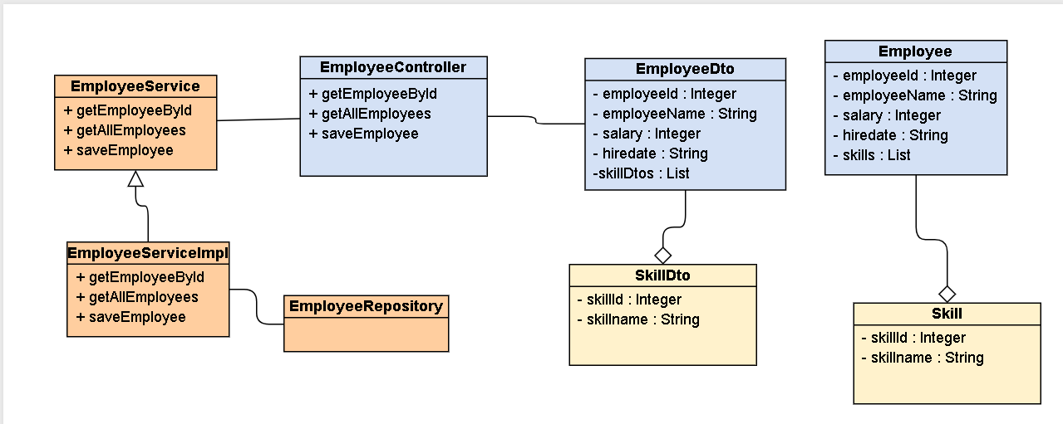

**Sequence diagram:**

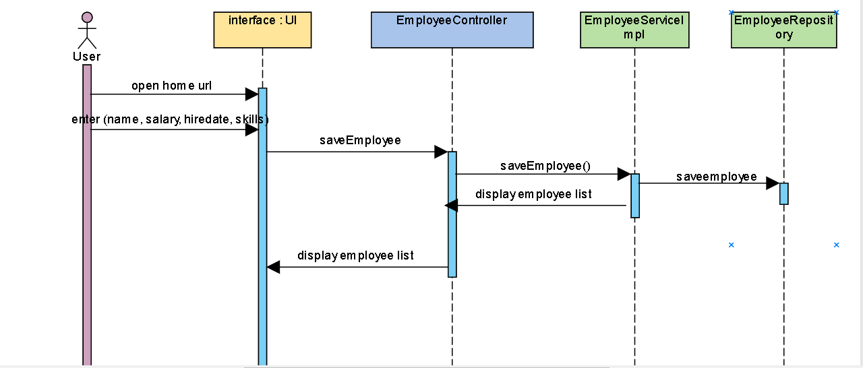

**API documentation**

1. **URL:** /home

**Method:** GET

**Return:** index.html

**Class:** HomeController.java

1. **URL:** /getAllEmployees

**Method:** GET

**Return:** List<EmployeeDto>

**Class:** EmployeeController.java

1. **URL:** /Save Employee

**Method:** POST

**Class:** EmployeeController.java